The Story of Penny and her ‘Miracle Puppies’
(including Dude, below)

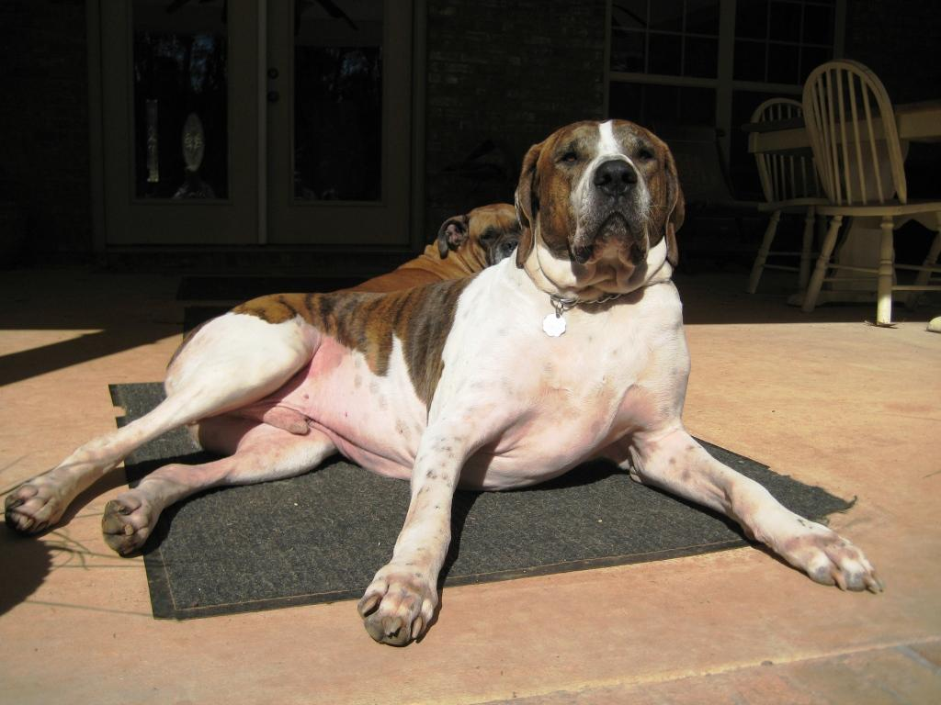

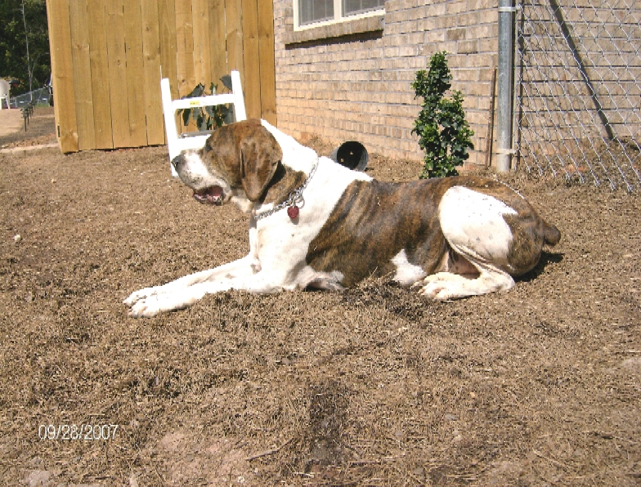

On February 13th, 2005, a large, starving, mange-ridden dog arrived in my yard, barely able to move. No one in the neighborhood had ever seen her before. A check with area agencies revealed that no one would accept her, except to put her down, in her severely emaciated condition. My vet (and long-time friend, Dr. Andrew ‘Joe’ Morrow of the Animal General Hospital in Columbus, GA) evaluated her and noted that her normal weight should be about 100 pounds, but her current weight was 58 pounds. He wasn’t sure of her breed. (Note: About two years later, we found out that she is an American Allaunt www.americanallaunt.com)

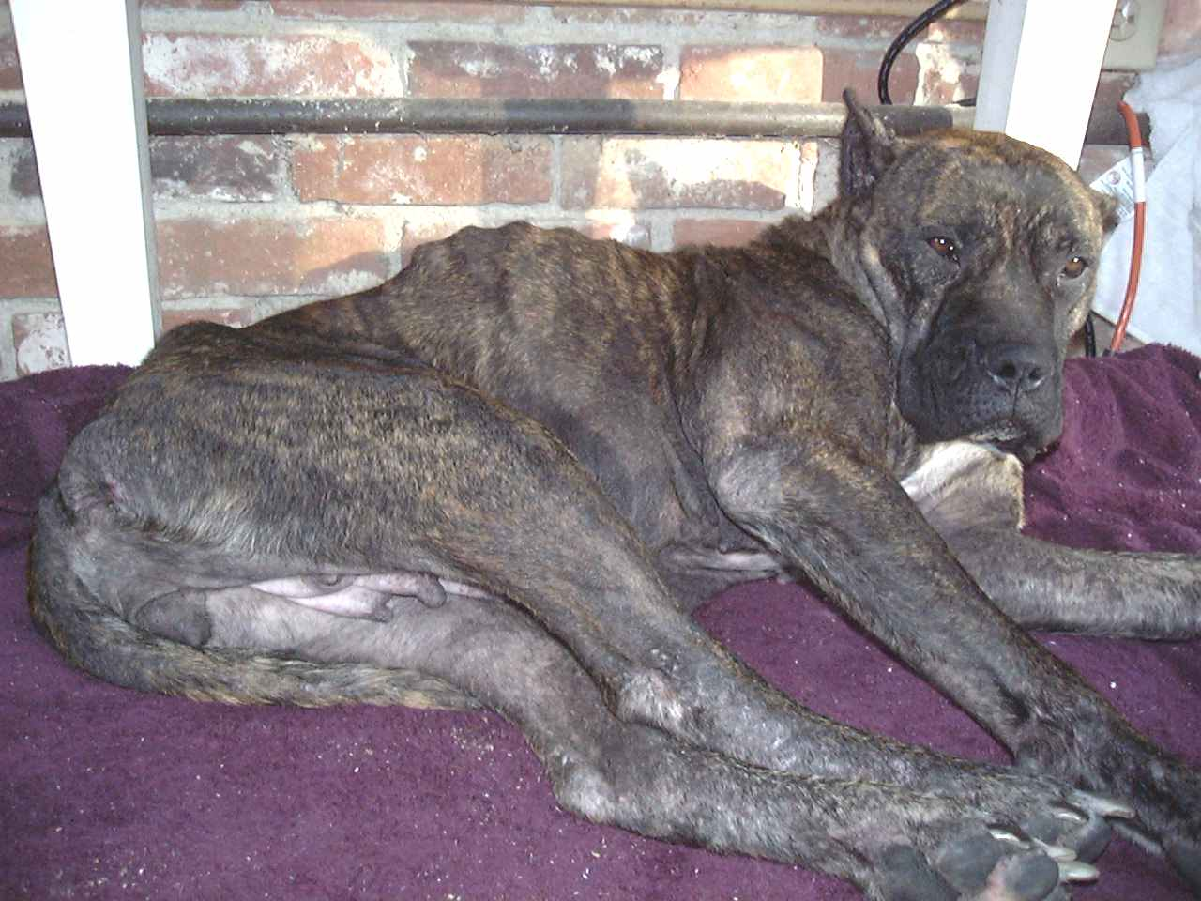

Since she seemed to have a good disposition and the blood tests showed no abnormal indications (other than extreme starvation and significant evidence of abuse), I decided to temporarily keep her with the intention of bringing her back to health and finding a good home for her.

One of the vets at the Animal General, Dr. Jennifer Saucier, took Penny on as her personal project, and worked with me closely. Three weeks later, she declared that Penny (since she was one ‘lucky penny’ that she came to my yard), though still severely thin, was much healthier. Then she told me the amazing news: Penny was pregnant when I found her! She said that they would be miracle babies if any of them survived, because it should not have been possible for Penny to sustain a pregnancy in her condition, even now. Also, she pointed out, the pregnancy and birth could be life-threatening for Penny. Dr. Saucier strongly suggested that we terminate the pregnancy for Penny’s sake, since the puppies probably wouldn’t otherwise survive the ordeal anyway.
The instant Dr. Saucier suggested terminating her pregnancy, I suddenly and completely understood the look Penny had in her eyes those past three weeks, what she had been trying so hard to tell me from the moment she found me: Penny wanted me to help her have those babies no matter what it took, no matter the risk. When I shared this with Dr. Saucier, she did an instant about-face, saying that she would help me do whatever it took to make this happen.

A couple of weeks later, on Saturday, March 19th, 2005 at 4:30 in the morning, Penny began having the first of five puppies in my laundry room, with me helping as an awed mid-wife. By 10am, it was clear that, although she was totally exhausted and her health was fading fast, there were still unborn babies in her womb.

I called Dr. Saucier, met her at the clinic and, via C-section, Penny delivered an amazing eight more puppies that morning-- a total of 13 puppies, and everyone survived the delivery—including Penny. Truly, these were miracle puppies.

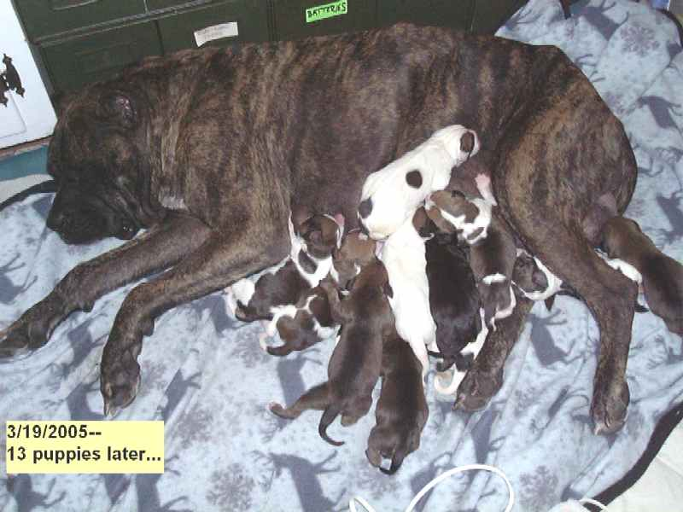

The litter had an amazing variety of different coat markings and colors, but they were very consistent in overall physique. Their noses were longer than Mom’s, with an almost ‘hound’ or pointer profile, including a handsome ‘peak’ at the back of their head. More significantly, unlike their mom’s short stubby ears, their ears were long, wide, and floppy— again, characteristically hound-like. Apparently, their father was an unusually large hound-related breed. Of course, we’ll never know for sure. All of the puppies, however, were obviously going to grow up to be very large and muscular, with tall strong legs and well-proportioned symmetry.
Because Penny was still significantly emaciated and in critical condition as a result of the births, I had to clean and hand-feed each of them four times a day. As the weeks passed, the litter grew healthy and strong, living in a large covered pen I put together under my 20’x20’ back porch. Penny slowly recovered and finally began gaining weight in earnest. Sadly, at five weeks, Brownie White Nose was apparently stung by a bee and was found dead in the pen.

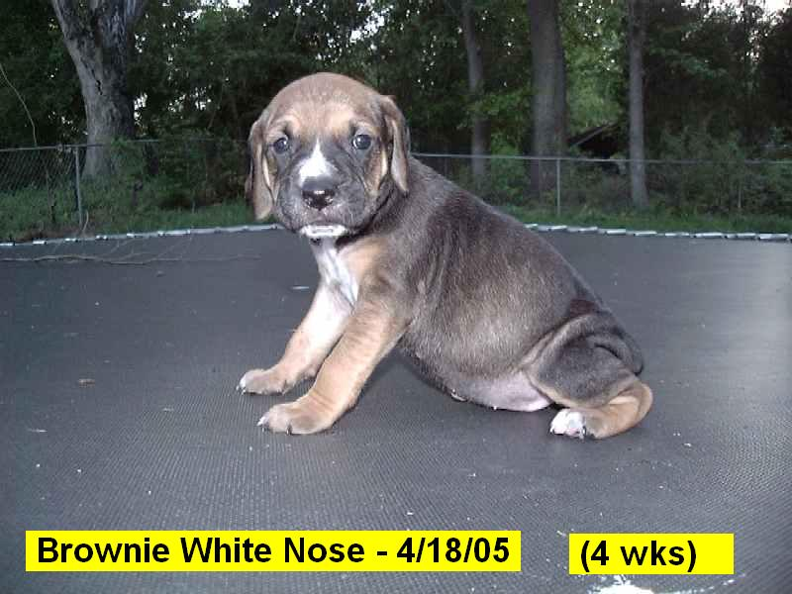

Once word got out that I had thirteen (now twelve) puppies to give away, potential owners began calling and coming by.



Despite a rigorous approval process, I had no trouble finding owners for all of them. The big giveaway date was scheduled for Saturday, May 14th, 2005, when they would be eight weeks old. I even found a great new home for Penny with a friend and her family.

In anticipation of losing the puppies to new owners, I wanted to make a brief video with title, nice transitions, ending credits, background music, and so on. So on Tuesday, May 10, 2005, I put each puppy on a large trampoline for a few moments of exclusive ‘face time’, walking back and forth on their canvas ‘stage’. Dude’s baby-name in the video, by the way, was ‘Lover Boy’. Only eight minutes long, the video can be seen by clicking here.

So sadly, on Friday, May 13, one day before their 8-week birthday, Bruiser (baby name ‘Rascal’) went from listless that morning to seriously ill by that afternoon. He had a liver shunt which, at a certain stage of overall growth, allowed unfiltered blood proteins to rapidly build up to a poisonous level. In a matter of hours, he went into continuous seizures and was suffering terribly. At about 4:30pm, I held Bruiser while Dr. Saucier put him to sleep.

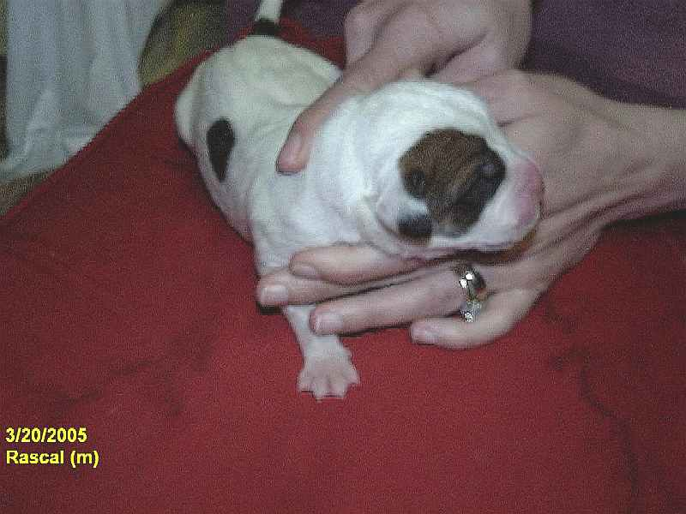

By Saturday afternoon, all the puppies’ new owners had come and taken them away. It was really hard for me to let them go after all I had shared with them in this incredible story.

This was a long exhausting saga— not only physically (especially the lack of sleep during the first few weeks after the puppies were born), but emotionally and financially as well. However, I am convinced that Penny somehow found and chose me to help her deliver her babies. It was a story of mutual love and trust: Penny somehow knew that I would do the right thing for her miracle puppies, and I did. I feel like I was the luckier of the two of us.

And how did Dude end up with me???

A few weeks after the initial giveaway, Dude’s original owner contacted me saying that an older male lab that they owned had become increasingly vicious with Dude as he grew larger. I gladly took him back and we’ve been together ever since.

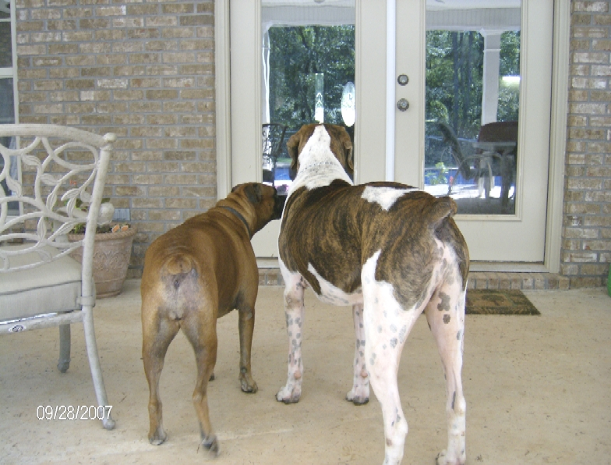

Dude quickly grew up to be a 140-pound giant. In the picture above, he’s standing next to his girlfriend, Grace, a full-sized boxer. Notice how tall he is compared to the standard sized chair to the left. He is 31” at the shoulders, with a 41” chest. He can eat food off the edge of a kitchen counter flat-footed.

This picture makes a good point: this is the side they usually offer to me because they want me to scratch their butts all the time. Nice to know I’m good for something, huh?

☺

